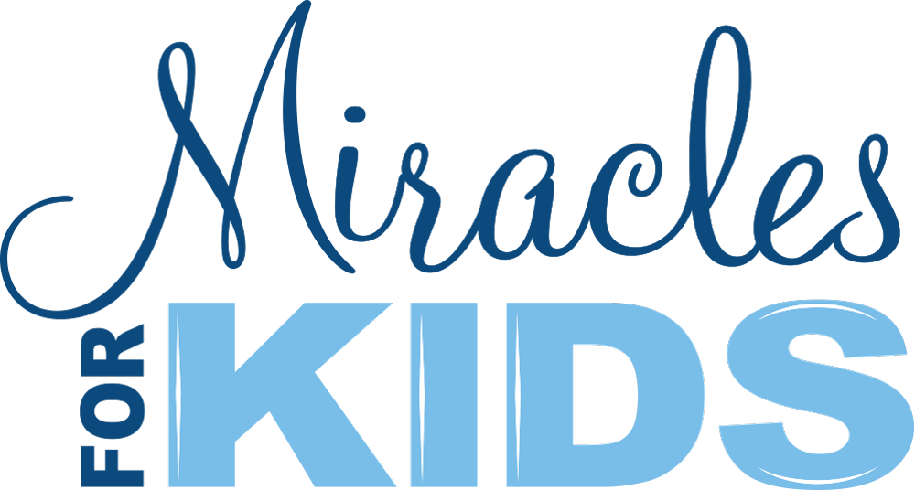

Miracles Annual Gala Raises A Record-Setting $3.83M for Critically-Ill Children and Their Families

Over 500 people attended the 17th Annual Night of Miracles, and more than 200 silent and live auction items were bid on to make more miracles happen!

IRVINE, Calif. – 2022: Over 500 attended the October 8th Miracles for Kids Night of Miracles Gala presented by Xponential Fitness, raising over $3.8 million (with donations pending from generous supporters not in attendance). One hundred percent of proceeds will go toward expanding programs that support a growing list of over 350 low-income families with children battling life-threatening illnesses and conditions.

“We are truly moved by the generosity of our sponsors and guests, who together helped us to raise nearly $4M for critically-ill children and their families in need,” shares Miracles for Kids Co-Founder/CEO Autumn Strier. “Our sincerest gratitude goes out to everyone who helped make miracles possible for those we serve.”

Anthony Geisler, Xponential Fitness, Inc. founder/CEO and presenting sponsor of the Night of Miracles Gala, commended the Miracles team for their ongoing work to fill in gaps for families whose children are critically ill. “We are honored to be a presenting sponsor again and to bring on board new sponsors, including Northern Trust,” Geisler said. “It is awe-inspiring to hear the stories of perseverance from these families whose kids are battling critical illness. We are proud to support this organization and its mission to deliver long-term stability solutions for low-income families with critically-ill children.”

Michele Havens, President of West Region, Northern Trust, shared that the gala sponsorship fits in with Northern Trust’s focus on improving health care and the lives of children in the communities it serves. “Northern Trust is proud to do our part to support Miracles for Kids and their invaluable assistance to families in their time of need,” she said.

This year, the organization’s signature event was “Masquerade” themed. Attendees each received a handmade rhinestone mask and custom candle, bringing light to the fear, anxiety, stress, and depression hidden beneath the surface of those who are struggling.

Attendees were able to bid on more than 200+ silent auction items and nine exclusive high-value live auction items. The live auction raised $333k and included two adorable Cavapoo female puppies ($12k and $13k each); a Luxury Charter in Spain for Up to 10 on a Multi-Million Dollar Yacht Night ($50k value); a Stay for Up to 10 at Casa Afrique, a Beachfront Luxury Villa in Punta Mita, MX (sold twice at $50k each); Round Trip Flight in Newly Renovated G550 to Any Western Destination ($70k); and a Marvel VIP Red Carpet Film Premiere Experience for 2 to two premieres ($18k/$11k).

The silent auction opened for bidding five days prior to the gala and raised $179,850 with over 200 items in the categories of Dining and Getaways, Fine Wines and Spirits, Sports and Entertainment, and Beauty and Novelty. Key items included Tequila Tasting with Mark Sanchez at the Monarch Bay Beach Club; a 3-Night Stay for up to 26 at “Vaquero” Private Estate and Vineyard in Temecula; a 7-Night Stay for up to 8 in a 3-Bedroom Villa in Punta Mita, MX; 2015 Sine Qua Non Magnum Set; and Christmas Day NFL Fun for 4: LA Rams vs Denver Broncos.

Supporters in the room also gave $1.45M directly in support of the mission, including a $1.25M matching gift by a longtime organization donor. Congratulations to longtime supporters Eric and Joan Davidson, for receiving the prestigious 2022 Miracle Maker award. The award designates a donor or donors each year who personify Miracles’ mission of making miracles for critically-ill children and their families. The Davidsons are longtime Miracles supporters, donors, and volunteers. Stephanie Morfitt, LCSW, was named Champion of Children for her work launching the organization’s original pilot mental health program.

Perhaps the most memorable moment of the evening was the standing ovation that followed a video sharing the story of 8-year-old leukemia patient Annabelle and her family. Other special guests included Kane Lim, Neil Everett, and from RHOC: Heather Dubrow and her husband Dr. Terry Dubrow, Gretchen Rossi, Slade Smiley and Jennifer Armstrong. Singer/songwriter Pia Toscano moved the crowd to tears with three original songs, including “Brave” plus new album releases “I’m Good,” and “Walk Through the Fire,” sharing the stage with courageous Miracles for Kids patients and siblings supported by the organization.

Miracles thanks the 200+ volunteers who donated 1,024 total hours to help make the event a phenomenal success. The organization also honors Presenting Sponsor Xponential Fitness, along with wine sponsors As One Cru and McClain Cellars; Jewelry Sponsor Kane Lim from Netflix’s Bling Empire; and Spirits Sponsors Duke Bourbon, La Adelita Tequila, and Tito’s Handmade vodka.

Become a change maker today through corporate sponsorship, live/silent auction participation/items, financial donations, and more: https://miraclesforkids.org/events/night-of-miracles-2022/.

# # #

About Miracles for Kids:
Miracles for Kids is a 501(c)(3) non-profit serving children with life-threatening illnesses and the families that care for them. Founded in 2002, and led by Co-Founder & CEO Autumn Strier for nearly 20 years, the organization creates stability for families that are crumbling from the financial and emotional devastation of fighting for their child's life. With programs providing financial aid, basic needs, housing, and wellness to patients and their families, Miracles fulfills a mission to help caregivers battle bankruptcy, homelessness, hunger, and depression, so they can concentrate on what matters most. Based in Irvine, California, the Miracles team currently serves families with children in treatment throughout the state, including CHOC Children’s Hospital, Children’s Hospital Los Angeles, UCLA Mattel Children's Hospital, Rady Children’s, UCSF Benioff Children's Hospital, and Loma Linda University Medical Center. Follow on Instagram @MiraclesForKids to see how your efforts make a difference. Learn more and discover ways to get involved at MiraclesForKids.org.

